**National University of Modern Languages**

**Artificial Intelligence - Lab**

**Assignment # 2**

**BSSE - 5 - Morning**

**Submitted By:**

Muhammad Umair – 12093

Talha Malik – 12089

**Submitted To:**

Sir Faiq

**TASK 1**

**Implement the decision Tree classifier to detect breast cancer.**

**Code:**

import numpy as np

import pandas as pd

import matplotlib.pyplot as plt

import seaborn as sns

from sklearn.model_selection import train_test_split

from sklearn.preprocessing import StandardScaler

data = pd.read_csv(r'E:\NUML\Semester Data\Semester 5\AI\AI Lab\12093_Muhammad Umair_A2\dataR2.csv')

print(data.head())

print("\nCancer data set dimensions : {}".format(data.shape))

x = data.drop('Classification', 'columns')

y = data['Classification']

x_train, x_test, y_train, y_test = train_test_split(x, y, test_size=0.25, random_state=5)

scaler = StandardScaler()

scaler.fit(x_train)

x_train=scaler.transform(x_train)

x_test=scaler.transform(x_test)

from sklearn.metrics import  confusion_matrix, classification_report, accuracy_score

from sklearn.tree import DecisionTreeClassifier

classifier = DecisionTreeClassifier(criterion= 'entropy', random_state=0)

classifier.fit(x_train, y_train)

y_pred_dt = classifier.predict(x_test)

print('Accuracy: ',accuracy_score(y_test, y_pred_dt))

cm = confusion_matrix(y_test, y_pred_dt)

print('Confusion Matrix: \n',cm)

plt.title("Heatmap of Confusion Matrix", fontsize = 15)

sns.heatmap(cm, annot= True)

plt.show()

print(classification_report(y_test, y_pred_dt))

**Output:**

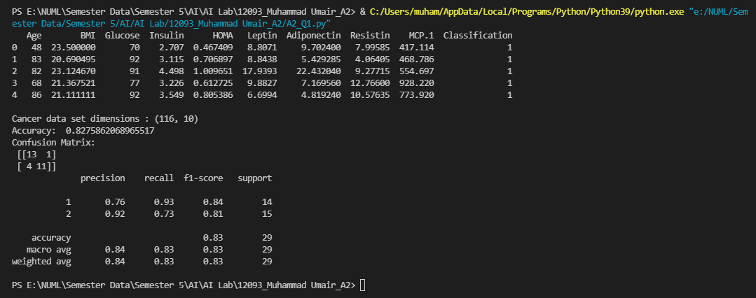

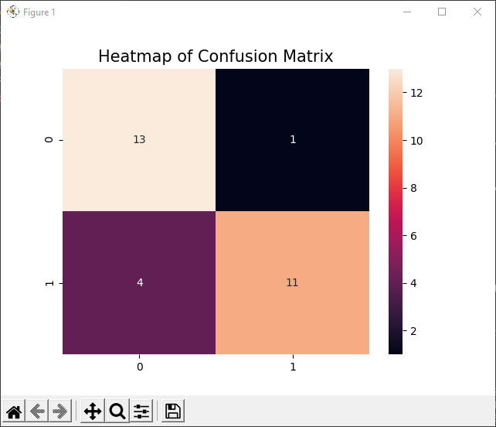

**TASK 2**

**Implement the logistic regression to detect breast cancer. Note: Standardize the data before training the model**

**Code:**

import numpy as np

import pandas as pd

import matplotlib.pyplot as plt

import seaborn as sns

from sklearn.model_selection import train_test_split

from sklearn.preprocessing import StandardScaler

data = pd.read_csv(r'E:\NUML\Semester Data\Semester 5\AI\AI Lab\12093_Muhammad Umair_A2\dataR2.csv')

print(data.head())

print("\nCancer data set dimensions : {}".format(data.shape))

x = data.drop('Classification', 'columns')

y = data['Classification']

x_train, x_test, y_train, y_test = train_test_split(x, y, test_size=0.25, random_state=5)

scaler = StandardScaler()

scaler.fit(x_train)

x_train=scaler.transform(x_train)

x_test=scaler.transform(x_test)

from sklearn.metrics import  confusion_matrix, classification_report, accuracy_score

from sklearn.linear_model import LogisticRegression

classifier = LogisticRegression(random_state = 0)

classifier.fit(x_train, y_train)

y_pred_lr = classifier.predict(x_test)

print('Accuracy: ',accuracy_score(y_test, y_pred_lr))

cm = confusion_matrix(y_test, y_pred_lr)

print('Confusion Matrix: \n',cm)

plt.title("Heatmap of Confusion Matrix", fontsize = 15)

sns.heatmap(cm, annot= True)

plt.show()

print(classification_report(y_test, y_pred_lr))

**Output:**

